Figure 6.x
Concertación slowly capturing the Senate
(Senators in office from parties tied to Concertación or appointed by President Frei)

Francisco Errázuriz convicted 22jan1999
Augusto Pinochet arrested in London 17oct1998
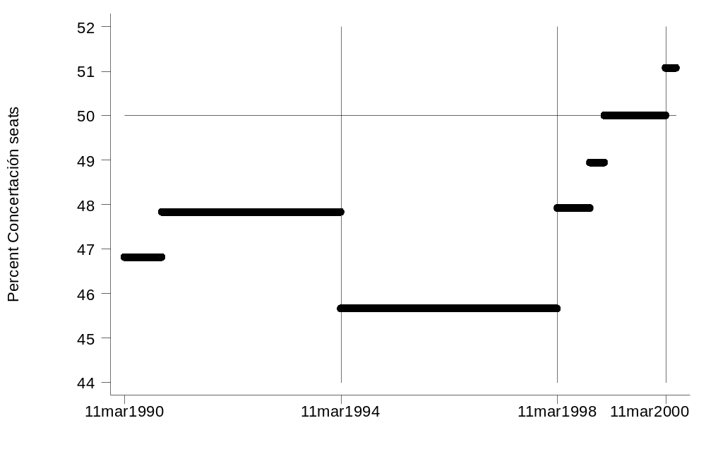
Sources: prepared with data from IDEAS [, 1992 #223] for 1990-94; the Senado web page at http://www.senado.cl/ (accessed Dec. 3, 1999) for 1994-98; and inferences from the previous two with guidance from the Ministerio del Interior web page at http://www.elecciones.gov.cl/ (accessed Feb. 15, 2000) for 1998-2000.
Appointed Senator César Ruiz Danyau dies in office 20nov1990
Eduardo Frei Senator for life 11mar2000

